Beacon Indoor Localization

Filip Mazán[1]*, Veronika Olešová[2]*, Filip Šoltés†,   
Michal Kučera[3]*, Daniel Pribul†, Jozef Karas[4]*

Slovak University of Technology in Bratislava

Faculty of Informatics and Information Technologies

Ilkovičova 2, 842 16 Bratislava, Slovakia

tim02.tp2014@gmail.com

People have problems with orientation in a new environment. Despite the fact, that most buildings have navigation boards, people are not able to find their destination and feel lost. Our solution helps these people – we are developing a method for localization, which will be tested in our application. It offers various information about activities within the building.

The application is currently adapted for one building – our faculty (named Virtual FIIT), but can be easily transferred to any other - business centers, shopping centers or hospitals. The main group of users are fresh students, but can be also any student or employee. Thanks to previous teams of developers, the application offers lots of functionality including viewing maps, personal timetable, canteens in the surroundings or bus departures. Our goal is to maintain these features, improve them and expand them to fulfill the needs of the users even better.

The previous development team deployed the application using PhoneGap technology. Their chosen technologies and programming techniques caused a lot of problems and slowed down the development. Therefore we decided to rebuild this application from scratch. We chose Ionic framework, which is suitable for developing multi-platform smooth running mobile applications. It utilizes AngularJS and CSS extension Sass and makes the development more efficient. The insight of our new design can be seen in the Figure 1a).

The most promising feature of our application is the possibility of localization of the user within a building. GPS technology can be used in open areas, but the satellite signal is too weak to reach insides of the buildings. This can be solved by different approaches (e.g. using Wi-Fi signal), but they are not always sufficient [1, 2]. In our project, we use Bluetooth LE technology utilized by Bluetooth beacons - tiny transmitters of low energy signal located in the building. Existing solutions [1, 3] using this technology are not precise enough - the average error is overall bigger than 3 meters. This is caused due to the nature of 5 GHz signal on which Bluetooth operates - the signal is easily interfered with and its strength fluctuates in time. This is why we decided to research this area ourselves and come up with another solution.

At first, we tried to localize the user by using trilateration algorithms. This algorithm did not work well, since it is needed to precisely estimate the distance of the Bluetooth receiver from the beacon transmitter. We found out, that the signal fluctuations in the building are too strong to estimate the distance, yielding errors more than five meters. These high errors practically made the trilateration useless. The next approach we tried is to utilize machine learning algorithms to be able to estimate user’s position based on the existing studies [1, 4]. We used simple multi-layered neural network, which was trained on gathered data from 4 Bluetooth beacons located in one part of the building of our faculty. We gathered 100 samples of received signal strength (RSSI) from 14 locations 2 meters from each other. Received signal strength (RSSI) and positions of beacons are shown in a heat map in the Figure 1b). Since the gathered data correlates with transmitter locations, it can be used to train a neural network. We used backpropagation training algorithm on a feedforward neural network with 4 input, 7 hidden and 2 output neurons. We trained it on 105 samples, but have not had more samples available for proper validation. The achieved average error is 3 meters. Although this number may seem high, it is very promising. Next network improvements should lower the error significantly.

Our vision is to navigate the user to his destination based on his current location in the building. If the error would be small enough, it could serve the visually impaired people as an aid or could be used for automatic localization and navigation for moving machines.

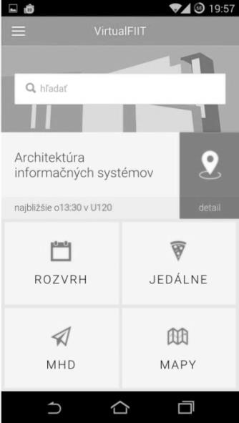 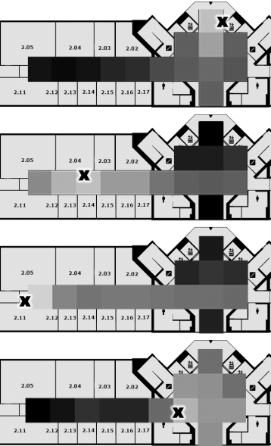

a) b)

Figure 1. a) Main screen of the application, b) Four Bluetooth beacon measurements of their signal strength and their position marked by X on one floor of the building

References

1. OKSAR I.: A Bluetooth signal strength based indoor localization method. In: *Proc. of Int. Conf. on Systems, Signals and Image Processing (IWSSIP)*. IEEE. 2014. pp. 251-254.
2. LI, X., LIU, X., LIU, K.: Guoguo: enabling fine-grained indoor localization via smartphone. In: *Proc. of the 11th annual int. conf. on Mobile systems, applications, and services*. 2013, pp. 235–248.
3. LU, T. et al.: Fusion of Wi-Fi and Bluetooth for indoor localization. In: *MLBS '11: Proc. of the 1st int. workshop on Mobile location-based service*. 2011, pp. 63–66.
4. AHMAD, U. et al.: In-building Localization using Neural Networks. In: *Proc. of IEEE International Conf. on Engineering of Intelligent Systems*. IEEE. 2006. pp. 1-6.

1. * Master degree study programme in field: Information Systems
2. † Master degree study programme in field: Software Engineering  
   Supervisor: Dr. Alena Kovárová, Institute of Informatics and Software Engineering, Faculty of Informatics and Information Technologies STU in Bratislava
3.
4.