BGP Lab
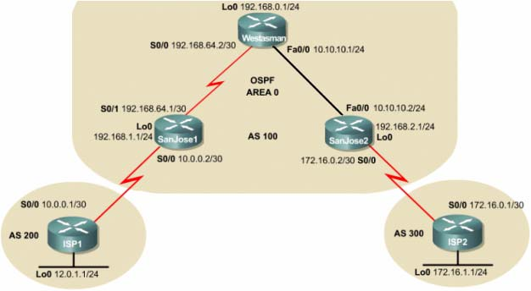

autostart = True

[localhost]
[[3640]]
image = C:\DATA\INstalls\GNS\images\c3640-ik9s-mz.124-16.bin
ram = 128
rom = 4
nvram = 128
# idlepc = 0x60493564
ghostios = True
sparsemem = True
chassis = 3640

[[ROUTER WESTASMAN]]
model = 3640
console = 2001
slot0 = NM-4T
s0/0 = R2 s0/0
s0/1 = R3 s0/0

[[ROUTER SANJOSE1]]
model = 3640
console = 2002
slot0 = NM-4T
s0/0 = R1 s0/0
s0/1 = R4 s0/0

[[ROUTER SANJOSE2]]
model = 3640
console = 2003
slot0 = NM-4T
s0/0 = R1 s0/1
s0/1 = R5 s0/0

[[ROUTER ISP1]]
model = 3640
console = 2004
slot0 = NM-4T
s0/0 = R2 s0/1

[[ROUTER ISP2]]
model = 3640
console = 2005
slot0 = NM-4T
s0/0 = R3 s0/1

FRAME RELAY 1 & 2
SET1
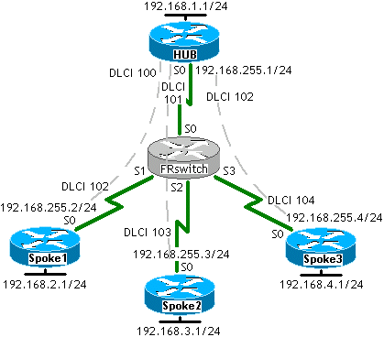
autostart = True
[localhost]

[[3640]]
image = C:\DATA\INstalls\GNS\images\c3640-ik9s-mz.124-16.bin
#idlepc = 0x605d5154
ram = 128
rom = 4
nvram = 128
sparsemem = True
ghostios = True
chassis = 3640

[[ROUTER HUB]]
model = 3640
console = 2006
slot0 = NM-4T
s0/0 = FR0 0

[[ROUTER SPOKE1]]
model = 3640
console = 2007
slot0 = NM-4T
s0/0 = FR0 1

[[ROUTER SPOKE2]]
model = 3640
console = 2008
slot0 = NM-4T
s0/0 = FR0 2

[[ROUTER SPOKE3]]
model = 3640
console = 2009
slot0 = NM-4T
s0/0 = FR0 3

[[FRSW FR0]]
0:100 = 1:102
0:101 = 2:103
0:102 = 3:104
1:102 = 0:100
2:103 = 0:101
3:104 = 0:102

SET2
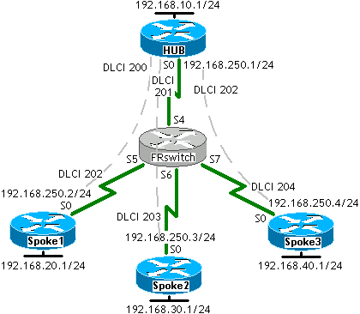

autostart = True
[localhost]

[[3640]]
image = C:\DATA\INstalls\GNS\images\c3640-ik9s-mz.124-16.bin
#idlepc = 0x605d5154
ram = 128
rom = 4
nvram = 128
sparsemem = True
ghostios = True
chassis = 3640

[[ROUTER HUB]]
model = 3640
console = 2006
slot0 = NM-4T
s0/0 = FR0 0

[[ROUTER SPOKE1]]
model = 3640
console = 2007
slot0 = NM-4T
s0/0 = FR0 1

[[ROUTER SPOKE2]]
model = 3640
console = 2008
slot0 = NM-4T
s0/0 = FR0 2

[[ROUTER SPOKE3]]
model = 3640
console = 2009
slot0 = NM-4T
s0/0 = FR0 3

[[FRSW FR0]]
4:200 = 5:202
4:201 = 6:203
4:202 = 7:204
5:202 = 4:200
6:203 = 4:201
7:204 = 4:202

DHCP Lab
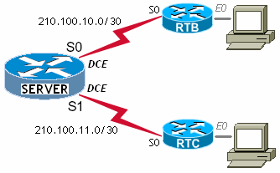

autostart = True
[localhost]

[[3640]]
image = C:\DATA\INstalls\GNS\images\c3640-ik9s-mz.124-16.bin
#idlepc = 0x605d5154
ram = 128
rom = 4
nvram = 128
sparsemem = True
ghostios = True
chassis = 3640

[[ROUTER RTC]]
model = 3640
console = 2024
slot0 = NM-4T
s0/0 = R11 s0/1
slot1 = NM-1FE-TX
f1/0 = hostC

[[ROUTER RTB]]
model = 3640
console = 2022
slot0 = NM-4T
s0/0 = R11 s0/0
slot1 = NM-1FE-TX
f1/0 = hostB

[[ROUTER SERVER]]
model = 3640
console = 2023
slot0 = NM-4T
s0/0 = R10 s0/0
s0/1 = R12 s0/0

