New Approach in Game Voice Control - Buzzing

Sašo Kiselkov, Bianka Kováčová, Martin Kozmon, Lenka Litvová, Michal Poláčik, Jakub Tekeľ
Slovak University of Technology
Faculty of Informatics and Information Technologies
Ilkovičova 3, 842 16 Bratislava, Slovakia
gang4six@centrum.sk
Abstract. This paper deals with design and prototyping of a 3D single player game named BloodLess - a humorous simulator of a mosquito with elements of an adventure. In comparison with other games, our simulator has a humane motive and educational character. The main contribution of our game is the game control - flight of the mosquito will be controlled by the frequency of player's buzzing. Using frequency control makes it easier for player to identify himself/herself with the main character and in this way makes our game unique in the area of 3D games.

Introduction
There are thousands of games in the world and still more of them are created every day. The games are placed in many realistic and also mystical worlds. There are tens of game genres. It is getting more and more difficult to create a really unique game with the ability to attract huge masses of players. One of the possible attractions is an unusual game control.
There are many approaches to game control. The most usual devices are keyboard and mouse. Making games more complex makes also game control more demanding on player’s interaction. Involvement of other human capabilities such as movement or voice makes game more attractive and easier to control.
We have aimed our effort to voice control, more specifically said to control with the frequency of voice. There are few games controlled by the loudness of voice, but all of them are very simple and the frequency control has been never used in a 3D game yet.
To make our game more interesting we want to put some humor and human motive in our game. And because we think that contemporary games are excessively violent and full of blood, we decided to use blood in a completely different manner and to enrich it by some educational character.

Comparison with similar projects
Our game puts together many interesting aspects, the most interesting of them are:
- humane motive (refill hospital blood supplies)
- educational character (need to differ between blood types)
- control by the frequency of voice
More detailed description of our project follows in the next sections.
The mosquito as the main character is really rare, but not unique. For example, in the playstation game Mister Mosquito [4] the player is a mosquito whose main goal is to suck sufficient amount of blood from members of a family who repeatedly do the same activities and moves. Another example is the PC game Mosquito Ops [5]. The goal is almost the same, but the player can move around the main building, not just inside. The weakest point of both games is a quite simple game world.
Typical controls as the keyboard and the mouse are nowadays supplemented by new forms of control. Voice is just one of these modern ways. In voice controlled games we have to distinguish between voice command control, as in the game LifeLine [3], and sound control, which typically uses the loudness of user’s voice. For the second type there are quite many 2D examples: Pah! [6], Shout n Dodge [7], Ford game [2]. These games are built at almost the same principle – the loudness of user’s voice controls one parameter – the high of the submarine/space shuttle in Pah! and Shout n Dodge or the speed of a car in Ford game.
There are games, which already contain one or two of these features, but they have never been used together in a single 3D game before.

Description of our project
The game BloodLess is a simulator of the life of an unusual mosquito. It combines the fun elements of an arcade-style flight simulator with the intellect developing elements of an adventure game. We also tried to add educational factors into our game, so that the player does not simply fly around and suck blood without purpose. There are many quests and minigames (some of them mentioned bellow), where the player's mind is motivated to develop both conscious and subconscious problem resolution skills.

Main idea
The mosquito in our game is not an ordinary mosquito. To keep the game captivating even after a few initial moments of play, we came out with a story about a mosquito that gets in touch with a mutagen substance in a secret laboratory underneath a hospital. This substance transforms it into a super-mosquito (in the Figure 1).
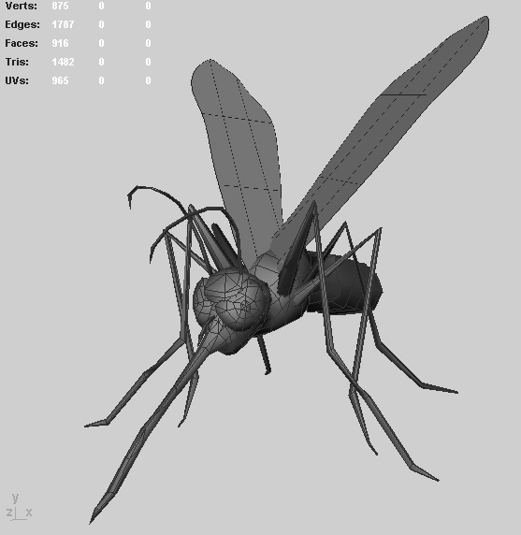
Fig. 1. The 3D model of the big super-mosquito.
The super-mosquito decides to help the hospital with blood supplies and sucks blood from people around the hospital. The player has to distinguish the blood types of course. The player gets points for blood which is properly distributed into appropriate blood canisters and loses them for mixing different blood types.
There are many improvements for the mosquito in the hospital, which the player can buy for points, thus transforming the relatively static story into a dynamic one. The requirement for blood is constantly increasing, so the player has to install new augmentations into his or her mosquito, in order to collect blood more quickly and efficiently. Besides time limits the player also faces other dangers in the virtual playground. The mosquito can get killed by people or other natural enemies such as dragonflies or swallows.

Motivation for players
Each game's primary goal is to entertain players. Our project has also an educational element to teach (in the first place younger) players about different blood types and that blood is a material of insufficient supply in the real world. We also put together several game concepts such as flight, adventure, fights and educational elements.

World
The game is situated in an unnamed city in a near future. The position of objects in the game is constant and the same for every game. The most important building is the hospital which is the central point of the story. The play area is confined and it is not possible to leave it. This restriction is handled with high buildings which the player cannot fly over (in the Figure 2).
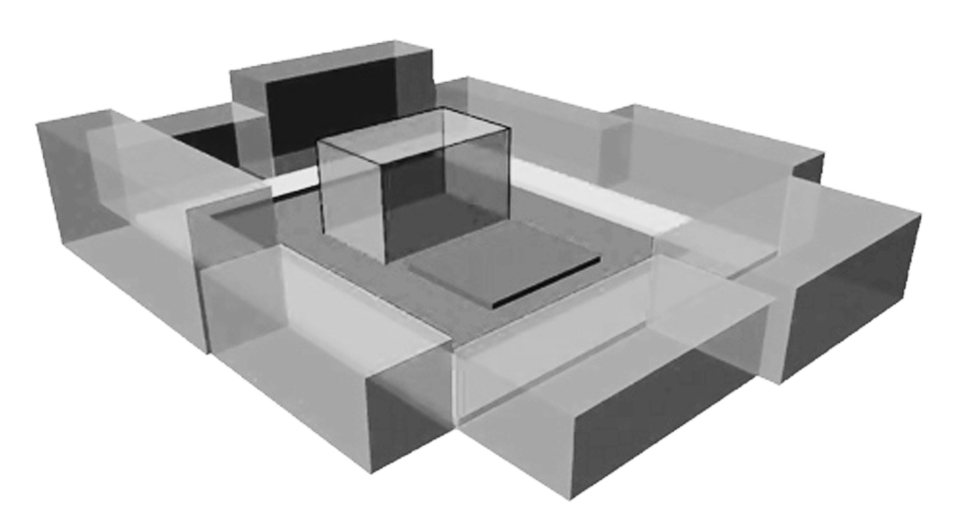
Fig. 2. The 3D model of the game world.
The player can fly in this area freely and pursue various activities, such as collect blood from people, which is the game's main activity, collect special items and complete quests and minigames.

Enemies
The people in the city have no idea about mosquito’s good intentions and that is why they are the most dangerous enemies for it. They try to kill it usually with their hands, but they do not pursue it and when they stay alone for a while, they return to their previous activity. This will be implemented as a conditional behaving.
The animals represent the second group of enemies. Some of them try to kill the mosquito and eat it. The mosquito can use its special improvements to defend itself from these animals, or it can simply try to fly away. These enemies are different from humans in the main fact that they represent aggressors towards the mosquito and will pursue it if possible.
The environment itself can also be considered an enemy. The mosquito can be killed by water, wind or fire – the game features a simple weather simulator.

Game objective
The player chooses quests himself – there is no linear game line. The quests can be found in different parts of the game area. There are two main types of quests.
First type of quests is associated with sucking blood. There can be handicaps like need of only specific blood type or time limit. The second type of quests is not related with sucking blood, e.g. killing infected animals, finding a father of a child according to their blood types, flight challenges.

Game control
The aim of our project was to make use of unconventional controls, but in the stage of designing the user interaction we had also to take into account all user needs. The way the game will be controlled should not affect the playability of the whole game. That is why we decided to combine more methods of interaction. To control the flight of the mosquito we decided to use the frequency of user’s voice and mouse.
Precision is needed to control the mosquito while the flight. To decide in which direction (up, down, right or down) mosquito should fly, the mouse is used. This is a field tested solution assuring the game playability.
Beside the need to control the direction there is also the need to control the speed of the mosquito. Here the frequency of user’s voice or better said the sound user is making comes into play. To achieve a high frequency player should make buzzing as a real mosquito does while flying. The Fast Fourier Transform (FFT) is used to compute the frequency from sound input. The Coley-Turkey implementation was used as the FFT needed to be performed in the time near to real [1].
In our game we used some of the basic physical principles, which apply in the aeronautics [8], to make the movements of the mosquito more realistic. Following equations apply to the vectors (respectively their lengths) of the forces
$A+B+F_{c}=X$ (1)
$A^{2}+B^{2}+F_{c^{2}}=X^{2}$ (2)
where X is the traction force, B is the moving force, F_{c} is the centripetal force and A is the upward force.
The frequency of user’s voice determines the traction force X, the mouse vertical axis determines the moving force B, the mouse horizontal axis determines the centripetal force F_{c} and the upward force is computed from equation (2).

Prototyping
Having analyzed pros and cons of several graphics and game engines for Windows, we came to the conclusion that Ogre3D best suites our needs. This graphics engine is on top of DirectX 9, is fast enough, easy to learn, well documented and with wide support from the developer community. Using it, we have implemented two prototypes in C++ – one prototype for each of the main game’s modules.
The first prototype shows a simple 3D scene consisting of four buildings, grass surface, sky with moving clouds and an animated mosquito character. For our purpose the player controls the mosquito by mouse and two keyboard buttons. The buttons are used to increase and decrease the frequency of flapping mosquito’s wings (buzzing control will be implemented later). Direction of the traction force is determined by the position of the mouse cursor on the screen. Real direction and speed of mosquito’s movement together with his tilt is then computed from the traction force vector, gravitation force, air resistance and the upward force.
This prototype offers the player the possibility to switch among three different camera modes: first person view, third person static view and third person chasing view. In the first mode, player looks in the same direction as the mosquito does and the player can not see the mosquito’s body. In the remaining camera modes, player looks from the mosquito’s behind. In the second mode, player can see the mosquito always in the same position on the screen. In the last and the most attractive mode, camera chases the character with a small time delay.
The second prototype demonstrates the recognition of buzzing sound. It records the sound input from microphone. On demand it decomposes the collected data into frequency components by the FFT and identifies the basic frequency.
In our opinion both prototypes confirm the viability of a 3D-game with voice-controlled main character.

Conclusions
In this paper, we described all characteristics of our product. The goal of our project is to create game with a fresh playing style. This is going to be accomplished by original game story, unusual main character and innovative game controls. Also important are the aspects of non-violent game play and teaching value of the game.
We are now looking forward to implement proposed ideas. Comparison with other existing works shows that there is a lot of space for new ideas. Therefore, it is possible that some additional features will come to our minds during implementation, which will enhance the game even more.
Acknowledgement: This work was partially supported by the Scientific Grant Agency of Slovak Republic under the contract No. VG 1/3103/06.
References
- Fast Fourier Transform. [Online; accessed February 27th, 2008]. Available at: http://www.relisoft.com/Science/Physics/fft.html
- Ford Game. [Online; accessed February 27th, 2008]. Available at: http://www.fordgame.be/
- Lifeline. [Online; accessed February 27th, 2008]. Available at: http://www.mobygames.com/game/ps2/lifeline
- Mister Mosquito. [Online; accessed February 27th, 2008]. Available at: http://en.wikipedia.org/wiki/Mister_Mosquito
- Mosquito Ops. [Online; accessed February 27th, 2008]. Available at: http://mosquitoops.damnr6.com/
- Pah! - The first voice-controlled game on the web. [Online; accessed February 27th, 2008]. Available at: www.designer.co.il/pah/
- Shout n Dodge. [Online; accessed February 27th, 2008]. Available at:http://www.weebls-stuff.com/games/shout+n+dodge/
- U.S. Department of Transportation, Federal Aviation Administration: Rotorcraft Flying Book. Flight Standards Service. 2004. [Online; accessed February 27th, 2008]. Available at: http://www.faa.gov/library/manuals/aircraft/media/faa-h-8083-21.pdf

Supervisor: Alena Kovárová, Institute of Applied Informatics, Faculty of Informatics and Information Technologies, STU, Bratislava

